

**Tribhuvan University**

**Faculty of Humanities and Social Science**

**A Project Report on**

**“FoodHouse”**

***In the partial fulfillment of the requirements for the degree of Bachelor in Computer Application***

**(BCA)**

**Submitted To:**

**Department of Computer Application**

**Ambikeshwari Campus**

**Submitted By:**

**Mr. Hemraj Kalathoki (112502032)**

**Ms. Roshani Dhital (112502082)**

**BCA 4th Semester**

2080-06-18

**Under the Supervision of**

**Mr. Subham Singh Gupta**



**Tribhuvan University**

**Faculty of Humanities and Social Science**

**Ambikeshwari Campus**

**Supervisor’s Recommendation**

I hereby recommend that this project prepared under my supervision by **Mr. Hemraj Kalathoki** and **Ms. Roshani Dhital** and entitled **“FoodHouse”** in partial fulfillment of the requirements for the degree of Bachelor of Computer Application is recommended for the final evaluation.

…………………….

**SIGNATURE**

**Mr. Subham Singh Gupta**

**Jhingaura, Ghorahi, Dang 22415**



**Tribhuvan University**

**Faculty of Humanities and Social Science**

**Ambikeshwari Campus**

**LETTER OF APPROVAL**

This is to certify that this project prepared by **Mr. Hemraj Kalathoki** and **Ms. Roshani Dhital** entitled **“FoodHouse”** in partial fulfillment of the requirements for the degree of Bachelor's in Computer Application has been evaluated. In our opinion it is satisfactory in the scope and quality as a project for the required degree.

|  |  |  |  |
| --- | --- | --- | --- |
| …………………..  **Mr. Subham Singh Gupta**  **Supervisor**  **Jhingaura, Ghorahi, Dang**  **22415** |  | …………………..  **Mr. Nabaraj Basel**  **HOD**  **Jhingaura, Ghorahi, Dang**  **22415** |  |
| …………………..  **Internal Examiner** |  | …………………..  **External Examiner** |  |

**Abstract**

“**FoodHouse**” is a web based application specially develop for the canteens and for hotels. This system have two main entities user and admin. User register with the provided details then only login if the email and password are correct. Admin have the full control to the system. Admin updates the food items into the item list that are available in the hotels, add users delete users, edit orders. Then user view the item-list table and make order as his choice.

In this way our system is developed to give easy service to the users who wants to make order through online. PHP, MYSQL are used as back-end development tools and HTML, CSS, Bootstrap-5, and JavaScript are used as front-end development tools.

**Acknowledgement**

We sincerely acknowledge and thank to those who have contributed their valuable time in helping us to achieve the success in our project work. We would like to express our gratitude to all those gave us the possibility to complete this project. We want to thank Ambikeshwari Campus for assigning **Mr. Nabaraj Basel** as a project head and also for his valuable and timely guidance, co-operation, encouragement & time spent for doing this project work.

We would also like to thank our Head of Department Mr. Chandra Prakash Khanal, senior **Mr. Paribartan Kalathoki** and project supervisor **Mr. Subham Singh Gupta** for their assistance and insightful comments, and who willingly shared their expertise with us. We are immensely obliged to our friends for their elevating inspiration, encouraging guidance and kind supervision in the completion of our project. We sincere thanks to the IT staff for providing us sufficient information which helped us to complete our project successfully. Last, but not the least, our parents are also an important inspiration for us. So, with due regards, we express our gratitude to them.

**Abbreviations and Acronyms**

BCA Bachelor of Computer Application

CSS Cascading Style Sheets

DFD Data Flow Diagram

ER Entity Relationship Diagram

HTML Hyper Text Markup Language

HTTP Hyper Text Transfer Protocol

IDE Integrated Development Environment

SQL Structured Query Language

UI User Interface

**Contents**

[Chapter 1: Introduction 1](#_Toc147338539)

[1.1 Introduction 1](#_Toc147338540)

[1.2 Problem Definition 1](#_Toc147338541)

[1.3 Objectives 2](#_Toc147338542)

[1.4 Scope and Limitation 2](#_Toc147338543)

[1.4.1 Scope 2](#_Toc147338544)

[1.4.2 Limitations 2](#_Toc147338545)

[1.5 Report Organization 2](#_Toc147338546)

[Chapter 2: Background Study and Literature Review 3](#_Toc147338547)

[2.1 Background Study 3](#_Toc147338548)

[2.2 Literature Review 3](#_Toc147338549)

[Chapter 3: System Analysis and Design 5](#_Toc147338550)

[3.1 System Analysis 5](#_Toc147338551)

[3.1.1 Requirement Analysis 6](#_Toc147338552)

[3.1.2 Feasibility Study 8](#_Toc147338553)

[3.1.3 Data Modeling (ER-Diagram) 9](#_Toc147338554)

[3.1.4 Process Modeling (DFD) 10](#_Toc147338555)

[3.2 System Design 12](#_Toc147338556)

[3.2.2 Database Schema 13](#_Toc147338557)

[3.2.3 Interface Design (UI/Interface Structure Diagram) 13](#_Toc147338558)

[3.2.4. Physical DFD 20](#_Toc147338559)

[Chapter 4: Implementation and Testing 21](#_Toc147338560)

[4.1 Implementation 21](#_Toc147338561)

[4.1.1 Tools Used 21](#_Toc147338562)

[4.1.2 Software Development Model 23](#_Toc147338563)

[4.2 Testing 25](#_Toc147338564)

[Table 2: Test Case for User Login 26](#_Toc147338565)

[Chapter 5: Conclusion and Future Recommendations 29](#_Toc147338566)

[5.1 Conclusion 29](#_Toc147338567)

[5.2 Lesson Learnt/Outcome 29](#_Toc147338568)

[5.3 Future Recommendations 30](#_Toc147338569)

[Appendices 31](#_Toc147338570)

[References 32](#_Toc147338571)

**List of Figures**

Figure 1: Use case Diagram ........................................................................................... 7

Figure 2: Entity Relationship Diagram (FoodHouse) .................................................. 10

Figure 3: 0 level DFD .................................................................................................. 11

Figure 4: DFD Level-1................................................................................................. 11

Figure 5: Level-2 DFD................................................................................................. 12

Figure 6: System Architectural Design ........................................................................ 12

Figure 7: Database Schema Design of FoodHouse ..................................................... 13

Figure 8: Home page of FoodHouse............................................................................. 14

Figure 9: Sign Up Page of FoodHouse......................................................................... 14

Figure 10: Login Page of FoodHouse........................................................................... 15

Figure 11: Menu Page of FoodHouse........................................................................... 15

Figure 12:Cart Page of FoodHouse.............................................................................. 16

Figure 13: User Profile Page of FoodHouse................................................................. 16

Figure 14: Ordered List Page of FoodHouse................................................................ 17

Figure 15: About Page of FoodHouse........................................................................... 17

Figure 16: Admin Dashboard of FoodHouse................................................................ 18

Figure 17: Orders Page of FoodHouse.......................................................................... 18

Figure 18: Users page of FoodHouse of admin………………………………………..19

Figure 19: Food category page of admin…………………………………………...…19

Figure 20: Physical DFD of FoodHouse………………………………………………20

Figure 21: Waterfall Model ......................................................................................... 23

**List of Tables**

Table 1: Test Case for Admin Login ........................................................................... 25

Table 2: Test Case for User Login ............................................................................... 26

Table 3: Test Case for User Registration ..................................................................... 26

Table 4: Test Case for Change Uesr Password ............................................................. 27

Table 5: Test Case for Order Food Item ....................................................................... 27

Table 6: Test Case for Add Food Item ......................................................................... 28

# Chapter 1: Introduction

## Introduction

In today’s fast-paced world, where time is a precious commodity, the convenience of online services has become a cornerstone of modern living. Among these services, online food ordering platforms have emerged as a transformative force in the culinary landscape. FoodHouse, a visionary project, is designed to bring the delectable world of cuisine closesr to people’s fingertips, redefining the way we dine. FoodHouse seeks to bridge the gap between culinary excellence and the desire for convenience. It provides a virtual gateway to a wide array of gastronomic experiences, catering to diverse palates and culinary preferences. From the savory delights of local eateries to international cuisine at your doorstep, FoodHouse brings a world of flavors to your table.

Our platform is committed to delivering a seamless ordering experience. With just a few clicks, customers can browse through a curated selection of restaurants, peruse menus, and customize their orders to perfection. FoodHouse empowers users with the ability to tailor meals to their preferences, ensuring every bite is a delightful experience. We understand the evolving needs of our users, and we continually strive to enhance the platform. Features like real-time order tracking, secure payment options, and user-friendly interfaces exemplify our commitment to providing an exceptional service.

FoodHouse is more than an online food ordering system; it's a culinary adventure waiting to be explored. Our commitment to quality, convenience, and community sets us apart in the realm of online food services. As you delve into this project report, you'll discover the intricacies of FoodHouse's development, the technology that drives it, and the impact it has on the modern dining experience.

## 1.2 Problem Definition

As people have to go to the canteens and hotels physically to know what items are prepared. Sometimes people do not have enough time to stay in line and ask for food. And also the crowd increases in hotels just to ask what items is special today. Breakfast time is fixed for the people in this busy time, they do not have any time to do discuss with the canteens or hotels administration.

Some of the major problems are:

* Customers are totally unknown about what items are going prepared in the cafeteria.
* Most of the people do not know the actual price of the items.
* Crowd of peoples in cafeteria just to ask for order.
* Customers do not have options to choose the items.

## 1.3 Objectives

Some of the objectives of this projects are:

* To update the available food items in the cafeteria.
* To give facilities to the people to view and order the items.
* To give the easy information to all the customers about the services.

## 1.4 Scope and Limitation

### 1.4.1 Scope

* It allows users to order food items online.
* It provides an admin to delete users.
* It provides an admin to manage the whole system.
* It updates the food items prepared in cafeteria.

### 1.4.2 Limitations

Some of the limitations of our projects are:

* Users cannot order foods without login.
* Online payment system is not available.

## 1.5 Report Organization

This report document contains five chapters including this chapter. Chapter two defines and describes Background Study and Overview of the related existing systems and their pros and cons. Chapter three presents the System and Design including Requirement Analysis and Feasibility Study Chapter four presents the Implementation, Testing and Debugging. Conclusion, Limitations and future Enhancement are briefly explained.

# Chapter 2: Background Study and Literature Review

## 2.1 Background Study

Today everything is digitalized. Internet make it possible, most of the business is online based. FoodHouse is online web-based application designed to solve the ongoing problem of most of the canteens cafeteria of the schools/colleges and other places. It makes easy for the users to see the items available in the cafeteria and hotels and order as per their wish. The administration updates the list of food items weekly or daily. And by seeing the list users make their decision which item to order, thus we designed this system to decrease the paper work and fully make digitalized.

## 2.2 Literature Review

The environment can exert a strong influence on people’s food decision. In order to facilitates customers to make healthier food choices and to develop healthy eating habits it is important that the school food, food environment that the school food environment is healthy. The healthy school canteen program is an intervention that helps schools make their cafeterias offerings cafeterias healthier.

According to Aquino, Correa, and Ani, (2014), they state that one of the basic needs of man is to provide the health requirement of a person in order to live. The availability of food on a plate of every Filipino is among the main concerns of the government in achieving food security. The Philippines has a numbers of policies being implemented that recognizes the pivotal role of improving food production and supply to meet the ever- growing food demand. However, more that availability and sufficiency of supply , food security is also defined as access to a safe and nutritious food(FAO,2014). Food safety refers to the assurance that food will not cause harm, human health is protected and market access of locally produced foods and food product is facilitated. [1]

Palacio, (2014), as cited by Boringot, (2016), that a continuous educational program for food service personnel is obligatory if a high standard of sanitation is to be maintained. This program should keep the employees aware of sanitary procedures and practices and why they are important. Also employees must continuously realize that heavy responsibilities that they, as food services personnel, assume for the health and well-being of their own good health,personal hygiene, work habits and the inherent dangers in the improper care of and handling of food should be emphasized. The educational program that combines the way, with the how to do is usually a wellorganized, systematic and functioning program. [2]

Shamrao et al, (2016), as the students’ attitude towards education has changing, colleges and their canteens must provide healthy and quality food to students. If the students are satisfied with quality, variety, and environment of the canteens then they will not go anywhere out of the college premise to get their food. Ultimately canteens requires that students want a quality food, environment and are willing to “pay” for it, possibly through higher priced foods, until this occurs it will be difficult for canteens to get benefit. [3]

# Chapter 3: System Analysis and Design

## 3.1 System Analysis

System Analysis is the process of studying a procedure in order to identify its goals and purposes and create systems and procedures that will achieve them in an efficient way. It is a problem solving technique that improves the system and ensures that all the components of the system work efficiently to accomplish their purpose. A systems analyst researches problem, plans solutions, recommends software and systems, and coordinates development to meet business or other requirements. The main goal of this system analyst is to collect different data from different site, process these data and generate progress as well as daily report. System analyst operates in a dynamic environment where change is a way of life. The environment may be a business firm, a business application, or a computer system. to construct a system the following key elements must be considered: -

**Input:** Input is what data the system receives to produce a certain output.

**Output:** What goes out from the system after being processed is known as Output. **Processing:** The process involved to transform input into output is known as Processing. Control: In order to get the desired results it is essential to monitor and control the input, Processing and the output of the system. This job is done by the control.

**Feedback:** The Output is checked with the desired standards of the output set and the necessary steps are taken for achieving the output as per the standards, this process is called as Feedback. It helps to achieve a much better Requirement in the system.

**Boundaries:** The boundaries are nothing but the limit of the system. Setting up boundaries helps for better concentration of the actives carried in the system.

**Environment:** The things outside the boundary of the system are known as environment. Change in the environment affects the working of the system.

**Interfaces:** The interconnections and the interactions between the sub-systems are known as the Interfaces. They may be inputs and outputs of the systems.

### 3.1.1 Requirement Analysis

Requirement analysis is done while developing a system and before implementing it, it is necessary to analyze the whole system requirement. It is categories into mainly two parts:

1. Functional requirements 2. Non-functional requirements

For any system, there are functional and nonfunctional requirements to be considered while determining the requirements of the system. The functional requirements are user “visible” features that are typically initiated by stakeholders of the system, such as generating reports, login, and sign up. On the other hand, non-functional requirements are requirements that describe how the system will do what it is supposed to do, for example, Usability, Reliability & Availability, Performance, Security and maintainability.[7]

**1.Functional Requirement:**

* Admin
* Can Login
* Can Add items
* Can Delete items
* Can Edit items
* Can Edit users
* Can Delete users
* Can See orders
* Can change order status
* Can Change Password
* Users
* Can Register
* Can Login
* Can Order items
* Can Check profile
* Can Give feedback
* Can Change password
* Can Logout
* Visitors

o Can View items

o Can Register

o Can See feedback

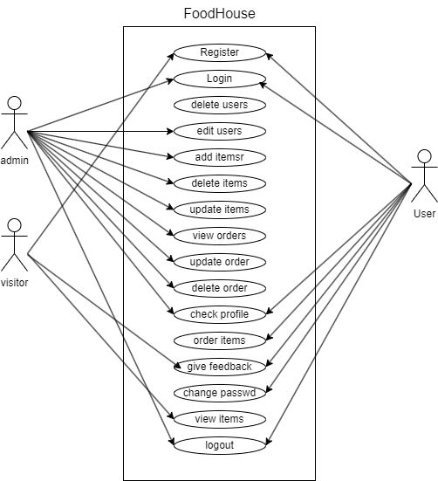

#### Figure 1: Use case Diagram

#### 2.Non- Functional Requirement

* Security: This system has accounts for its users and only authorized users can access the system with email and password. The password are encrypted using a PHP function md5().
* Availability: This system is available to users anytime, anywhere, just need a PC or mobile and Internet connection. Also, the system works in multiple web browsers like (Chrome, Mozilla and Opera).
* Reliability: This system keeps all the information of the users securely. This system gives quick and quality food items to the students. The system will provide the service 6 days a week. Only the cooked items are updated in the menu list.
* Maintainability: This system is easy to maintain by the developer or the authorized or trained person. Thus basic PHP is used to develop this system so any person having basic knowledge of PHP can main this system.
* Usability: This system is easy to use, user have to first register and then just login to have access the system. Different buttons are available for performing different actions.

### 3.1.2 Feasibility Study

After doing the project FoodHouse, study and analysis all the existing or required functionalities of the system, the next task is to do the feasibility study for the project.

Feasibility study includes the consideration of all the possible ways to provide a solution the given problem. The proposed solution should satisfy all the user requirements and should be flexible enough so that future changes can be easily done based on the future upcoming requirements.

* Economically Feasibility:

This is the very important aspect to be considered while developing a project. We decided the technology based on minimum possible cost factor. All the hardware and software are freely available that we have used to built this system. Over all we have estimated that the organization will get the benefits using this system and there no doubt it will uplifts the economic status of the organization.

* Technical Feasibility:

As per our study our system is technically feasible. We develop this system using the technology available with us. We do not have to invest any extra amount for technology during development.

* Operational Feasibility:

Our system is fully GUI based that is very user friendly, every user can use our system. No any extra training is required to use it.

* Schedule Feasibility:

In scheduling feasibility, an organization estimates how much time the project will take to complete. To calculate and continually re-examine whether it is possible to complete all the amount and scope of work lying ahead, utilizing the given number of resources, within the required period of time. In our project we used the Gantt Chart for the Schedule feasibility study.

### 3.1.3 Data Modeling (ER-Diagram)

This ER (Entity Relationship) Diagram represents the model of this project (FoodHouse). The entity-relationship diagram of the project shows all the visual instruments of the database table and the relations between admin, users, items and credit customers etc. It uses structured data to define the relationship between structured data groups of FoodHouse functionalities.[6]

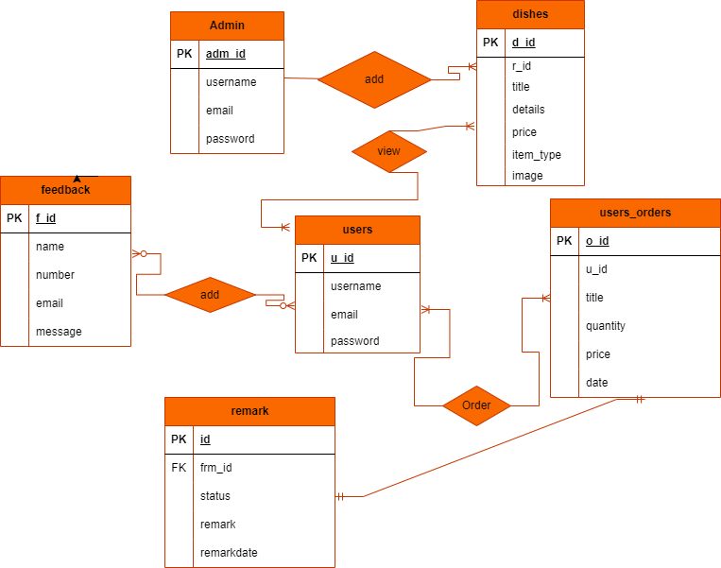

#### Figure 2: Entity Relationship Diagram (FoodHouse)

In the above ER Diagram, we can see clearly all the relation between the entities. There are four total entities in this project and they have their respective attributes. Here admin has all authorize to manage the users, he can delete users, add users, also edit user personal details. And user can only view and order the items.

### 3.1.4 Process Modeling (DFD)

Data flow diagram is graphical representation of flow of data in an information system. It uses defined symbols like rectangles, circles and arrows, plus short text labels, to show data inputs, outputs, storage points and the routes between each destination. Data flowcharts can range from simple, even hand-drawn process overviews, to in-depth, multi-level DFDs that dig progressively deeper into how the data is handled.

#### DFD Level-0

The 0 Level DFD shows flow of data of application. DFD Level 0 is also called a

Context Diagram. It’s a basic overview of the whole system or process being analyzed or modeled.

C:\Users\LENOVO\Desktop\FoodHouse_dfd_level_0.png

#### Figure 3: Level-0 DFD

#### DFD level-1

DFD Level 1 provides a more detailed breakout of pieces of the Context Level Diagram. This DFD describes main functions carried out by the system, as we break down the high-level process of the Context Diagram into its sub-processes.

#### Figure 4: Level-1 DFD

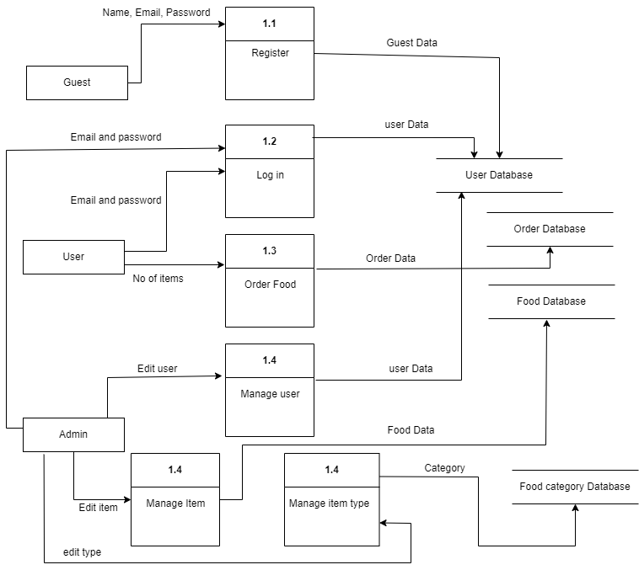

#### DFD Level-2

The DFD 2 Level describes flow of data in more detail. DFD Level 2 goes one step deeper into parts of Level 1. It may require more text to reach the necessary level of detail about the system’s functioning.

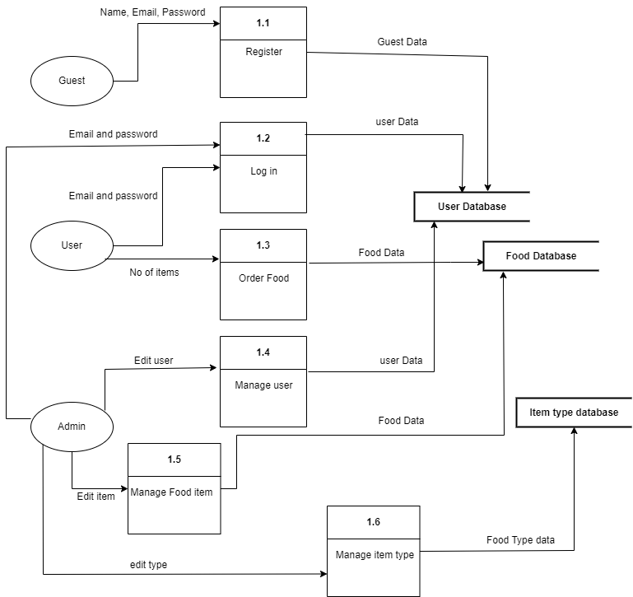

**Figure 5: Level-2 DFD**

# 3.2 System Design

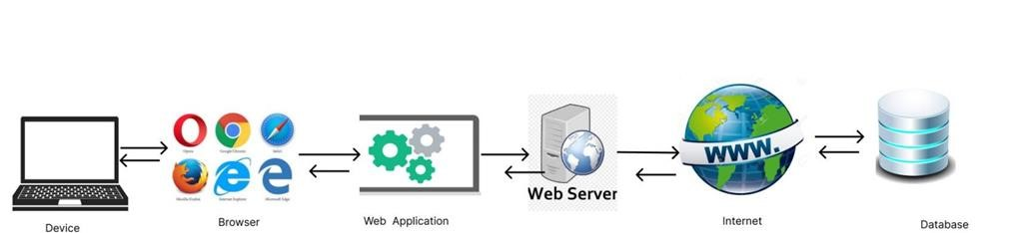

#### Figure 6: System Architectural Design

The next phase of design will be planning the architecture of the application. FoodHouse makes the use of internet and computer peripherals. This system is supported by any device that can access the internet. The system architecture is clearly displayed in the figure above.

### 3.2.2 Database Schema

A database schema is the skeleton structure that represents the logical view of the entire database. It defines how the data is organized in a system.

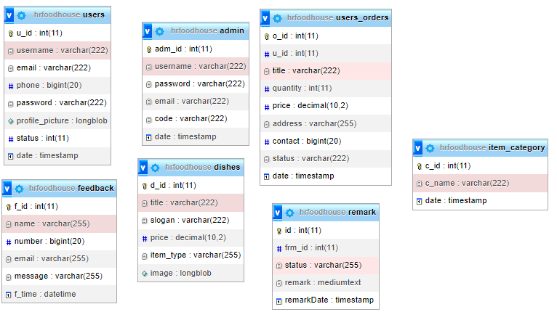

##### Figure 7: Database Schema Design of FoodHouse

### 3.2.3 Interface Design (UI/Interface Structure Diagram)

Before implementing the actual design of the project, a few user interface designs are constructed to visualize the user interaction with the system as they browse for view, order, register, login. The user interface design will closely follow our Functional Decomposition Diagram showing the initial designs of the web pages.

**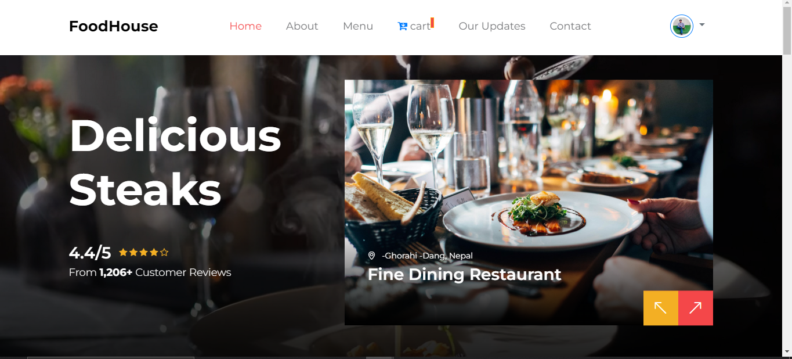**

##### Figure 8: Home page of FoodHouse

**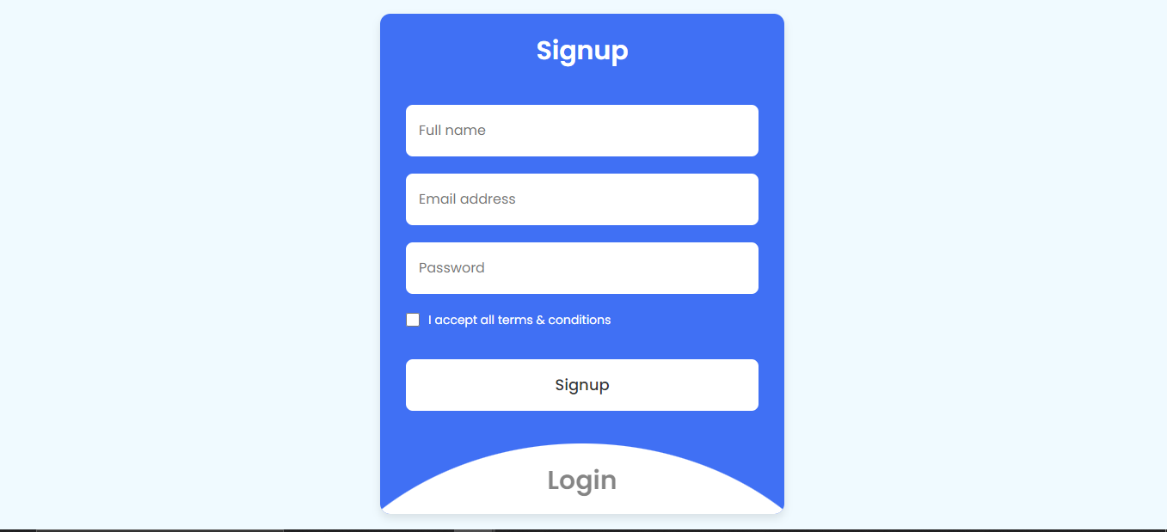**

##### Figure 9: Sign Up Page of FoodHouse

**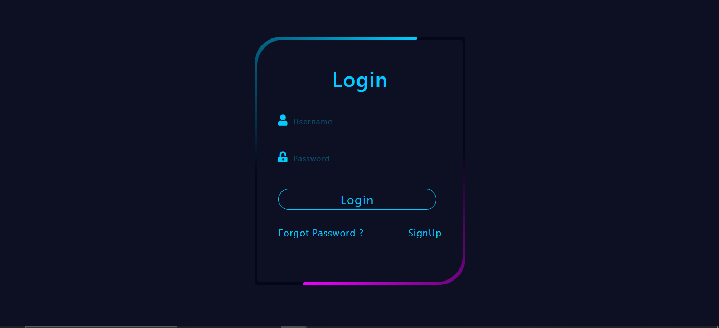**

##### Figure 10: Login Page of FoodHouse

**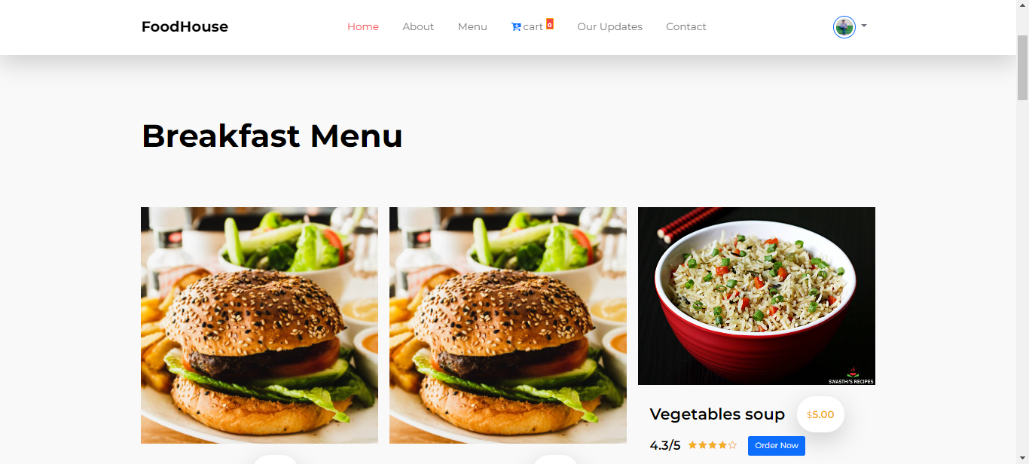**

##### Figure 11: Menu Page of FoodHouse

**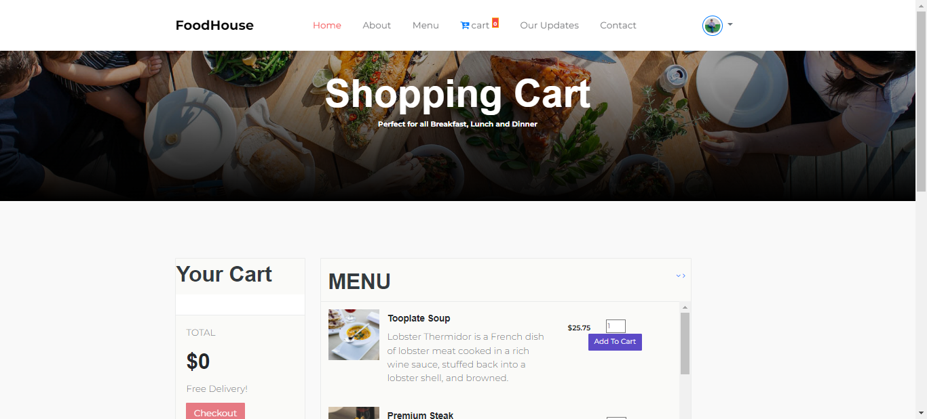**

##### Figure 12:Cart Page of FoodHouse

**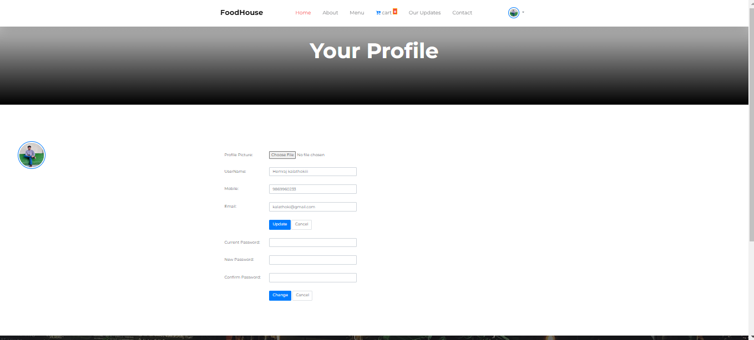**

##### Figure 13: User Profile Page of FoodHouse

**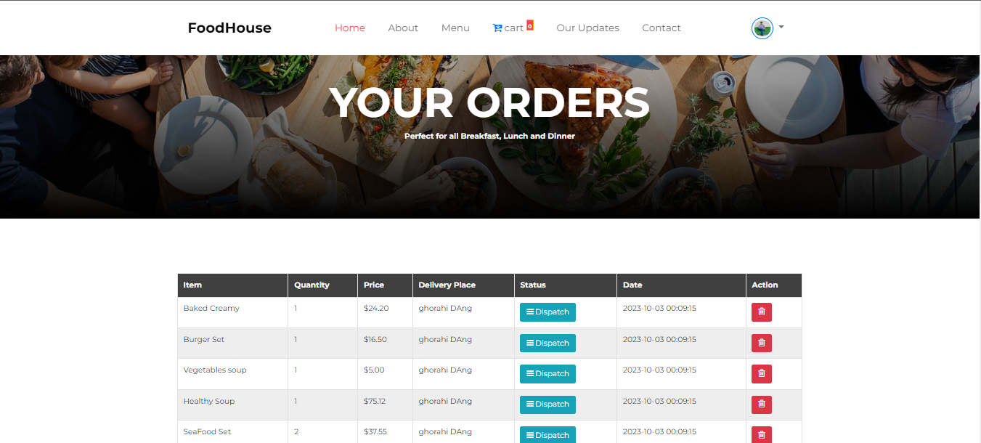**

##### Figure 14: Ordered List Page of FoodHouse

##### 

**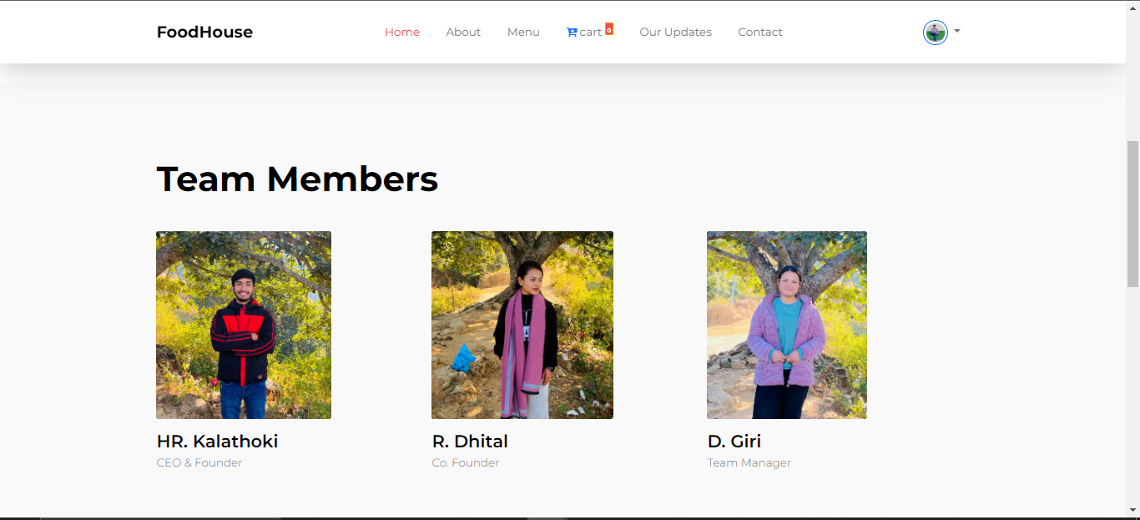**

##### Figure 15: About Page of FoodHouse

**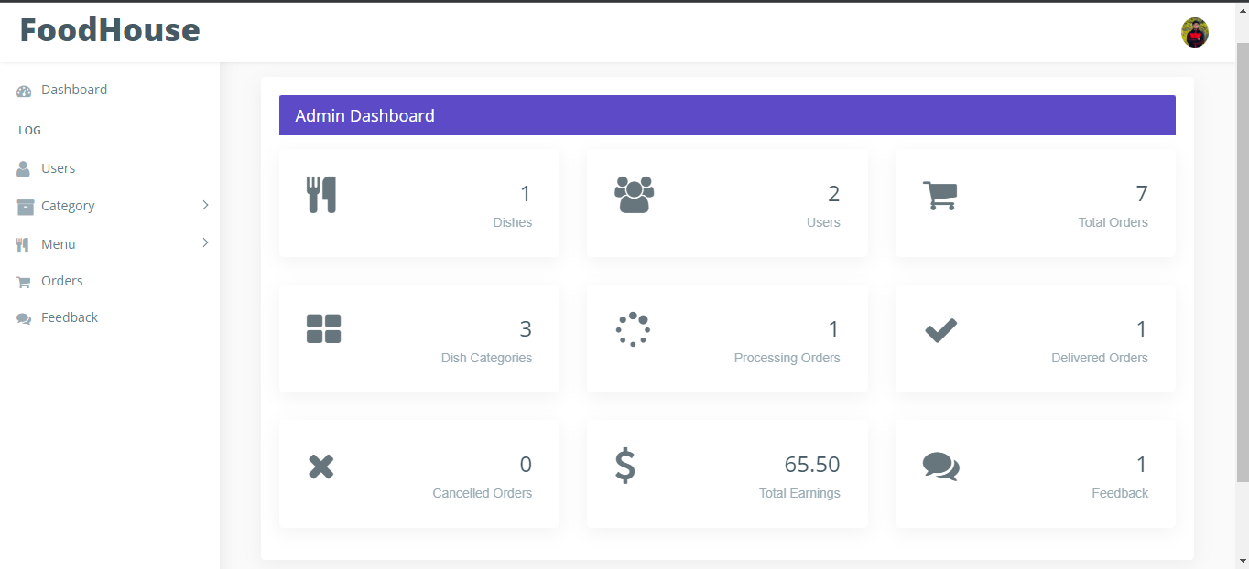**

##### Figure 16: Admin Dashboard of FoodHouse

**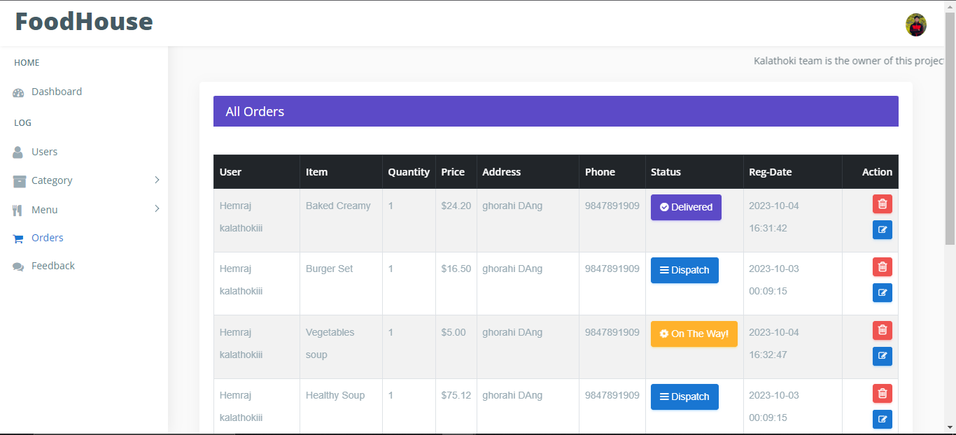**

##### Figure 17: Orders Page of FoodHouse

**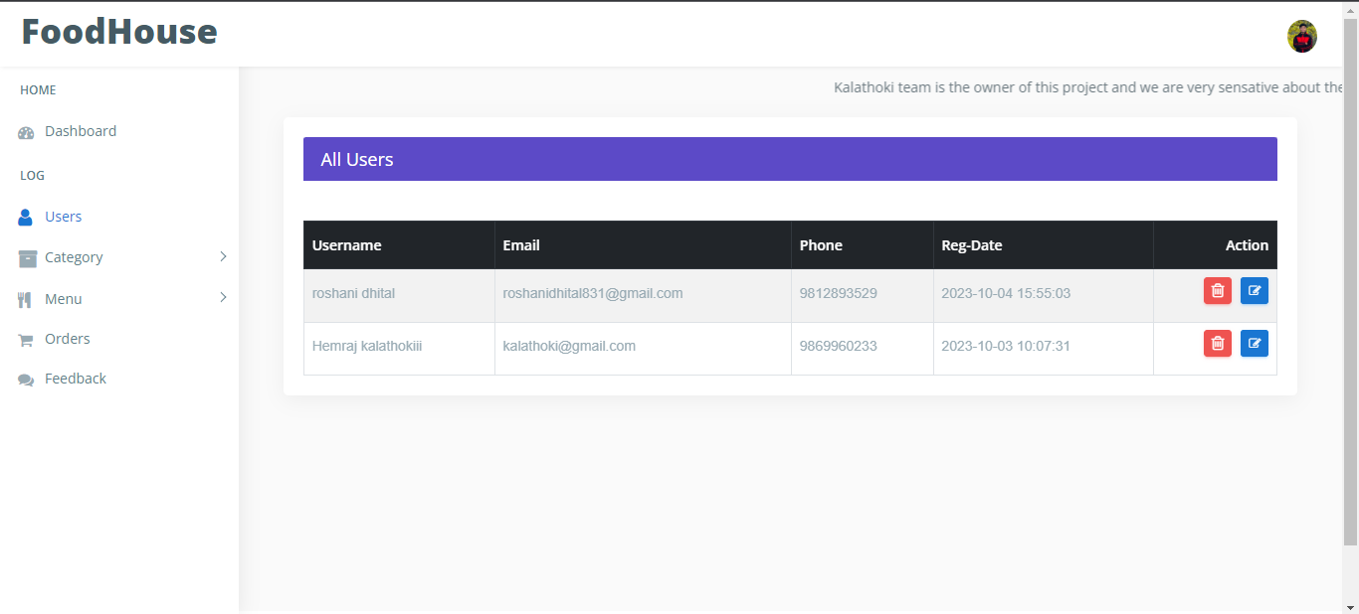**

##### Figure 18: Users page of FoodHose Admin

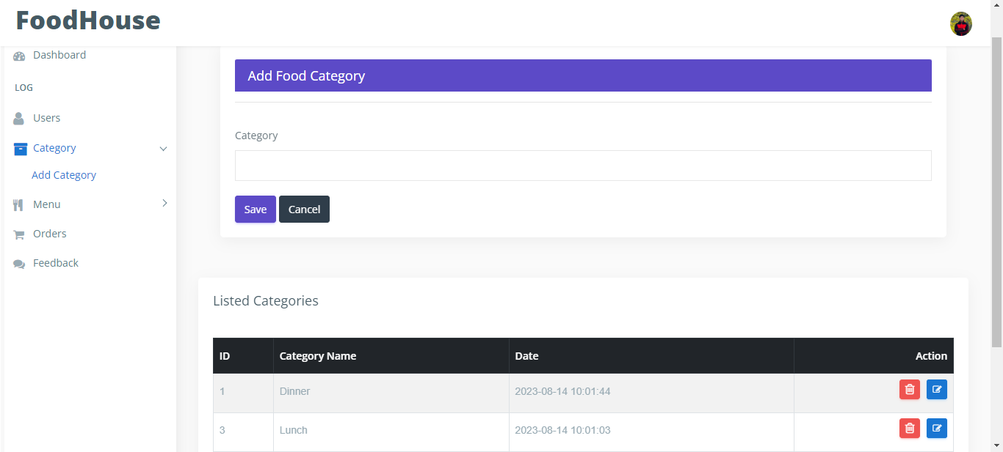

##### Figure 19: Food Category page of admin side

### 3.2.4. Physical DFD

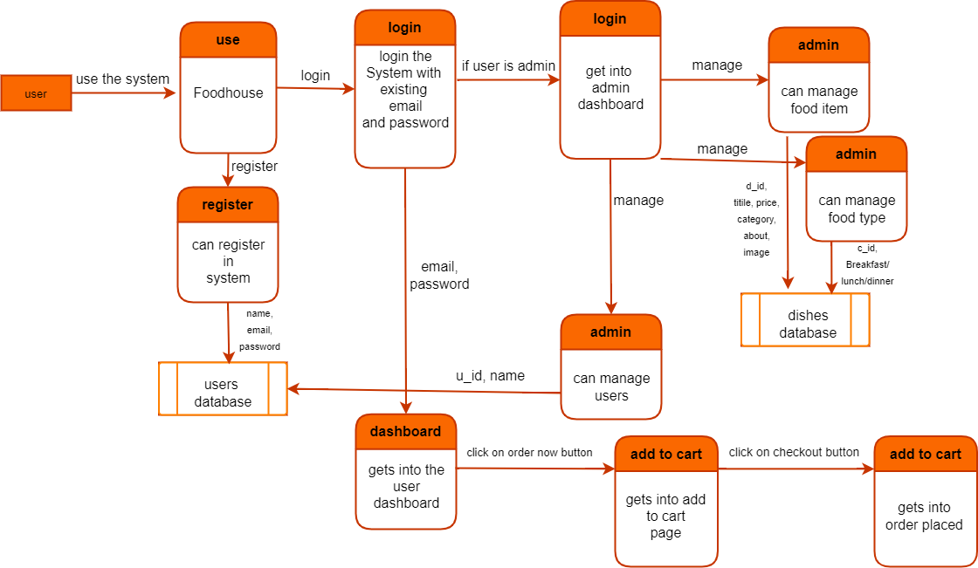

#### Figure 20: Physical DFD of FoodHouse

Here in the above physical dfd we can clearly see that first of all the user uses the system, if the user is a verified user then he/she can easily log in to the system by entering the valid email and password, but if he/she is just a guest then he/she can sign up for free whose data gets stored into the database and after signing in he/she is redirected to the login page which after logging in he/she can view and order foods he/she likes. If the user is admin, then he/she will be redirected to the dashboard in which he/she can view all the details of the users, can manage all the users and manage product and products details. The admin can also add and delete the categories. If the admin edits any user or products then the updated data is stored into the user database or the product database respectively. If the user clicks on the order now button he/she likes then it will redirect to the add to cart page, and if he/she clicks on the checkout button then it will take he/she to the payment gateway for check out.

# Chapter 4: Implementation and Testing

## 4.1 Implementation

After designing the system, the only thing that needs to be done is implement it so that we can release it as per the user satisfaction. Implementing the system requires a lot of resources and explanation which will not be completely explained in this report; however, some major aspects of the system are described below:

### 4.1.1 Tools Used

##### 4.1.1.1 PHP

PHP is an open-source language and all its components are free to use and distribute. PHP is server-side scripting language. It is embedded in HTML source code. PHP supports all major web servers such as Apache, Microsoft IIS and Netscape etc. All the major database such as Mysql, PostgreSQL, Oracle, Sybase, Microsoft SQL Server is supported by PHP. Following are the some major advantages:-

* Friendly With HTML - PHP and HTML are interchangeable within the page. You can put PHP outside the HTML or inside.
* Interactive Features - PHP allows you to interact with your visitors in ways HTML alone can't.
* Top-Notch Online Documentation - The PHP documentation is the best on the web. Hands down.
* Compatible With Databases - A good benefit of using PHP is that it can interact with many different database languages including MySQL.

##### 4.1.1.2 MySQL

MySQL is the most popular open source relational database management system. It is one of the best RDBMS being used to develop web-based applications. It is easy to use and fast RDBMS. Following are the top reason to use MySql:-

* High Performance
* Robust Transactional Support
* Strong Data Protection
* Open -Source Freedom

##### 4.1.1.3 HTML

Hypertext Markup Language (HTML) is the standard markup language for creating web pages and web applications. With Cascading Style Sheets (CSS) and JavaScript, it forms a triad of cornerstone technologies for the World Wide Web. Web browsers receive HTML documents from a web server or from local storage and render the documents into multimedia web pages. HTML describes the structure of a web page semantically and originally included cues for the appearance of the document.

##### 4.1.1.4 CSS

Cascading Style Sheets (CSS) is a style sheet language used for describing the presentation of a document written in a markup language like HTML. CSS is a cornerstone technology of the World Wide Web, alongside HTML and JavaScript. CSS is designed to enable the separation of presentation and content, including layout, colors, and fonts. This separation can improve content accessibility, provide more flexibility and control in the specification of presentation characteristics, enable multiple web pages to share formatting by specifying the relevant CSS in a separate .css file, and reduce complexity and repetition in the structural content.

##### 4.1.1.5 JavaScript

JavaScript often abbreviated as JS, is a high-level, interpreted programming language. It is a language which is also characterized as dynamic, weakly typed, prototype-based and multi-paradigm.

##### 4.1.1.6 Visual Studio Code

Visual Studio Code was announced on April 29, 2015 by Microsoft at the 2015 Build conference. A Preview build was released shortly thereafter. On November 18, 2015, Visual Studio Code was released under the MIT License and its source code posted to GitHub. Extension support was also announced. On April 14, 2016, Visual Studio Code graduated the public preview stage and was released to web. Visual Studio Code is a source code editor developed by Microsoft for Windows, Linux and macOS. It includes support for debugging, embedded Git control, syntax highlighting, intelligent code completion, snippets, and code refactoring. It is also customizable, so users can change the editor's theme, keyboard shortcuts, and preferences. It is free and open-source, although the official download is under a proprietary license.

##### 4.1.1.7 draw.io

Draw.io is proprietary software for making diagrams and charts. The software allows we to choose from an automatic layout function, or create a custom layout. They have a large selection of shapes and hundreds of visual elements to make our diagram or charts one-of- a-kind. Then drag-and drop feature makes it simple to create a great looking diagram or chart.

### 4.1.2 Software Development Model

Software development model is the series of processes used in software development. The commonly used methodologies include agile development methodology, waterfall method and rapid application development. There are few other methodologies depending upon the nature and objective of the software. In developing our entire system, we used the Waterfall Development Model. This was the most suitable model for our system. In addition, this model is very simple and easy to understand. Each phase must be completed before the new phases start, so there is no overlapping in the phases. The different development cycle was broken down into a sequence of processes and thus the development of FoodHouse was progressed. The following illustration is a representation of different phases of the waterfall model:

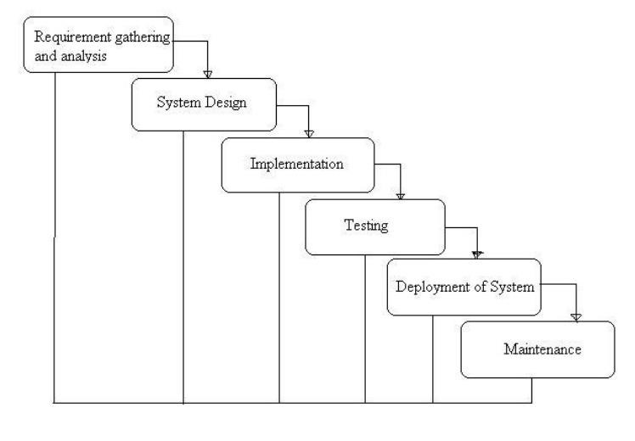

#### Figure 21: Waterfall Model

The above figure shows us the implementation of Waterfall Model. Being the most suitable model to use in our application we followed its approach where we would only continue to next module after the completion of previous module.

The following is the representation of different stages of waterfall model:

1. **Requirement Gathering and Analysis:** Before developing the system, it is crucial for requirement collection, and analysis. This phase was used to determine all such requirements that helped to make our product complete. Who are our stakeholders, what will be the nature of our users? We physically visited the fields/canteens and collect data. What are the problem facing by the canteen managers? What types of system they want? After the requirement gathering process was complete, these requirements were carefully applied during the software development.
2. **System Design:** In this phase, the framework of the proposed system was designed from the requirements which were addressed in the data collection phase. This stage will be useful in specifying the needed hardware and system requirements, including the system structure.

1. **Implementation:** Our implementation phase started with the completion of our designing phase. In this stage, we used different programming paradigms to design the system from the previous stage. It was kept in mind that the system development cycle needs to be robust. Simplified, and general-purpose programming techniques were used throughout the project.
2. **Testing:** After our platform was developed, the code was tested to see their feasibility. The use case requirements were in line with the details that were listed out in the requirement specification phase. Errors that occurred during the development stages were reduced to minimal.
3. **Deployment of System:** Once thefunctionaland non-functional testing is done, product is deployed in the customer environment or released in the market.

Thus, in this phase product is given to user to use.

1. **Maintenance:** After the product is deployed there are some issues which come up in the client environment. To fix those issues, patches are released. Also, to enhance the product some better versions are released. Maintenance is done to deliver these changes in the customer environment.

## 4.2 Testing

A test case is a set of conditions or variables under which a tester will determine whether an application, software system or one of its features is working as it was originally established for it to do.

**4.2.1 Manual Testing**

We both acted as a tester and tested most of the major and minor functionalities of web app and recorded the outputs on the tables below:

#### Table 1: Test Case for Admin Login

|  |  |  |  |  |  |
| --- | --- | --- | --- | --- | --- |
| **ID** | **Test Case Description** | **Test Data** | **Expected Result** | **Actual**  **Result** | **Pass/Fail** |
| TC\_01 | Admin  enters a wrong  userName | username :roshani  password: hemraj | Display message  Invalid username or password | As expected, | Pass |
| TC\_02 | Admin  enters a wrong  password | Username : kalathoki  password: dhital | Display message  Invalid username or password | As expected, | Pass |
| TC\_03 | Admin  enters correct username and password | Username: hradmin  password: hradmin | Logged into admin dashboard | As expected, | Pass |

### Table 2: Test Case for User Login

|  |  |  |  |  |  |
| --- | --- | --- | --- | --- | --- |
| **ID** | **Test Case Description** | **Test Data** | **Expected Result** | **Actual**  **Result** | **Pass/Fail** |
| TC\_04 | User enter wrong email | email : hr@gmail.com  password: @hemraj9869 | Display message  Invalid username or password | As expected, | Pass |
| TC\_05 | User  enters a wrong  password | Username : hemraj@gmail.com  password: @roshaihr9869 | Display message  Invalid username or password | As expected, | Pass |
| TC\_06 | User  enters correct email and password | Username: hemraj@gmail.com  password: @roshani9869 | Logged into  user dashboard | As expected, | Pass |

#### Table 3: Test Case for User Registration

|  |  |  |  |  |  |
| --- | --- | --- | --- | --- | --- |
| **ID** | **Test Case Description** | **Test Data** | **Expected Result** | **Actual**  **Result** | **Pass/Fail** |
| TC\_07 | User selects already existing email | Name: Kalathoki  Email: roshanihr@gmail.com  Password:@hemraj9869 | Display message username already exist | As expected, | Pass |
| TC\_08 | User enters all the details  successfully | Name: Roshani\_HR  Email:  roshanihr@gmail.com Password:@dhitalhr9869 | Display message registered successfully | As expected, | Pass |

#### Table 4: Test Case for Change User Password

|  |  |  |  |  |  |
| --- | --- | --- | --- | --- | --- |
| **ID** | **Test Case Description** | **Test Data** | **Expected Result** | **Actual**  **Result** | **Pass/Fail** |
| TC\_09 | User enter Wrong old password | Old\_password: @kalathoki  New\_password:@hemraj  Confirm\_password:@hemraj | Display message wrong old password | As expected, | Pass |
| TC\_10 | User enters mismatch new password two times | Old\_password: @roshani9869  New\_password:@kalathoki  Confirm\_password: @hemraj | Display message Enter same password in confirmation | As expected, | Pass |
| TC\_11 | User enters  All details  Correctly | Old\_password: @roshani9869  New\_password:@kalathoki  Confirm\_password: @kalathoki | Display message password updated successfully. | As  Expected. | Pass |

#### Table 6: Test Case for Order Food Item

|  |  |  |  |  |  |
| --- | --- | --- | --- | --- | --- |
| **ID** | **Test Case Description** | **Test Data** | **Expected Result** | **Actual**  **Result** | **Pass/Fail** |
| TC\_12 | User Try  to  make order  without login | Email: ………………..  Password: ………….... | Redirect to login page | As expected, | Pass |
| TC\_13 | User make order after  Login | Email: [kalathoki@gmail.com](mailto:kalathoki@gmail.com)  Password: @roshani9869 | Item added to cart | As expected, | Pass |

#### Table 5: Test Case for Add Food Item

|  |  |  |  |  |  |
| --- | --- | --- | --- | --- | --- |
| **ID** | **Test Case Description** | **Test Data** | **Expected Result** | **Actual**  **Result** | **Pass/Fail** |
| TC\_14 | Admin leaves empty field | Dishname: Sukuti  Item\_type:  Price: $50  Image:  Description: | Display message All  Fields must be required | As expected, | Pass |
| TC\_15 | Admin  Enters all  Required details of item. | Dishname: Sukuti  Item\_type: lunch  Price: $50  Image: sukuti.jpg  Description: Best buff sukuti. | Display message Item  Added successfully | As expected, | Pass |

# Chapter 5: Conclusion and Future Recommendations

# 5.1 Conclusion

Our goal was to create an application where people can view and order food items online. The current application has fulfilled these goals. I followed the specifications strictly but enhanced some of the features when there was need for it to be done. With the goals achieved the basis of the application and this project has been achieved. Building this web application has been challenging and enriching because throughout the project I learnt a lot about PHP and, JavaScript and understand what it takes to build a fully functional website. There have been challenges especially when it came to backend and making sure that the application responses in a predictable. Careful planning made our job easier because I had to carefully think about the type of architecture, the design, the database types to use and what type of business objects to create. When this was done, we proceeded with implementation.

Choosing the PHP for this project is because it is very simple and easy to use, compared to another language, this is widely used all over the world. it is Open source; we can freely download and use.

As we came to the end of the project, we realized that there are many enhancements that can be made on the application. Some of these ideas came from those who tested the application and some of them from both of us. I decided to follow the specification because there were realistic to achieve in this given amount of time. Any other enhancements to the application can be done in future development of the application.

# 5.2 Lesson Learnt/Outcome

When this project is completed, the users will be able to view and order food items online. After filling the register form, user can view and order items online through web browser.

# 5.3 Future Recommendations

Here is what can be added in the future on this website to increase its usability, user experience and portability of the website. There is a lot to be done hence this application can be considered as a starting point for something big to come. It will need more time and resources for all these to be done but it is still very realistic and possible to achieve.

1. We can build android app.
2. Online payment system can be added.
3. We can make the frontend part much more attractive.
4. We can add more features as per the user requirement.
5. We can make project device compatible.
6. We can make good user profile.
7. We can make addition of dark themes
8. Making Databases more efficiently.

# Appendices

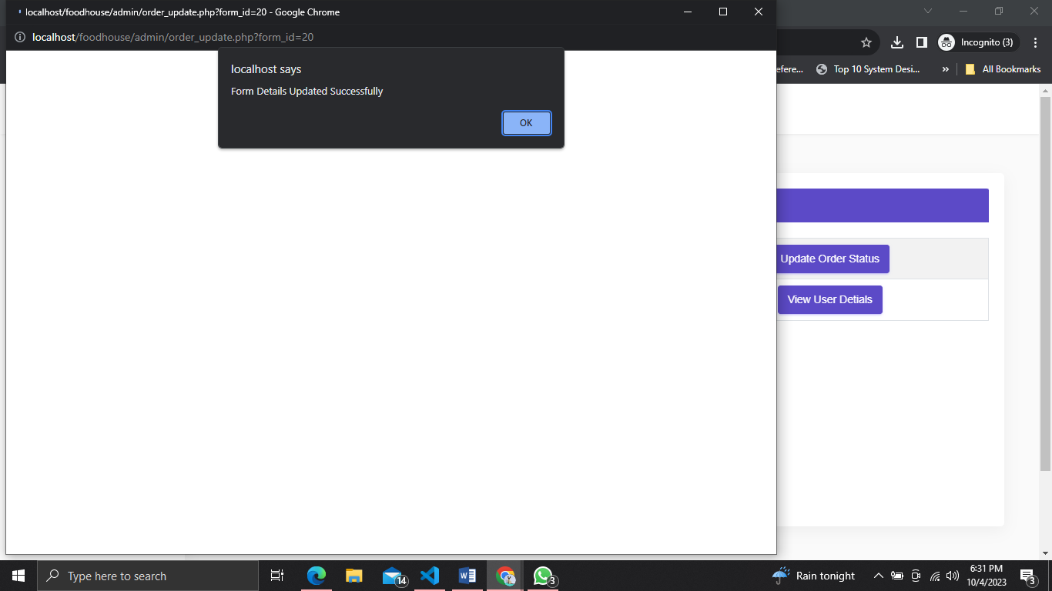

##### Figure 22: change order status by admin

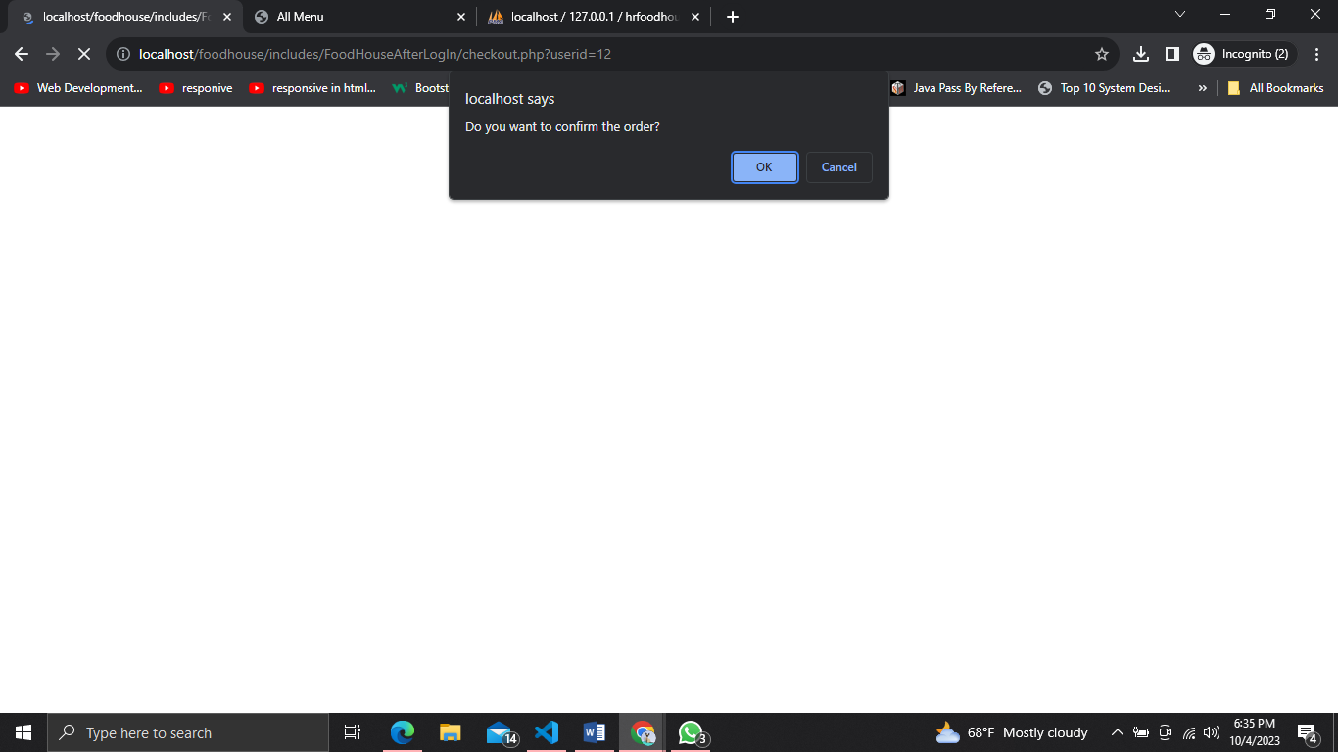

##### Figure 23: When user make order.

# References

# 

1. L.review," https://www.efacility.in/cafeteria-management-system/

[Online].

1. "https://meeraacademy.com/dfd-diagram-for-online-shopping-website/".
2. Geeksforgeek, "Architectural design in software enginnering overview," 19 dec 2021.